MYSQL VIEWS
2520030151--------P.MADHULIKA

Setup: Employees and Departments Tables
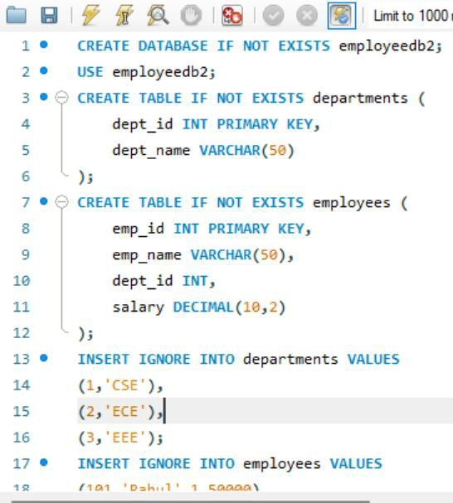

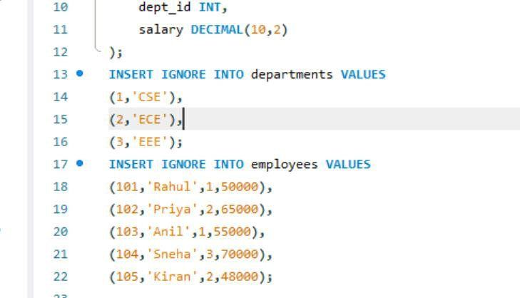

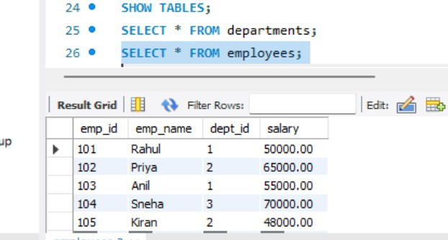
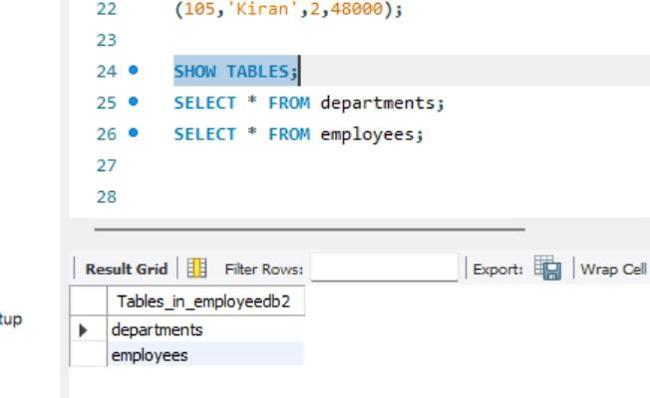
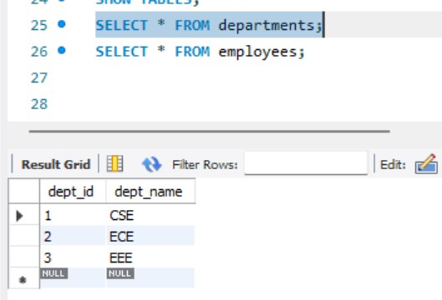
- Verify the Tables

View 1 – Display All Employees
Question: Create a View named EmployeeView to display all columns from employees.
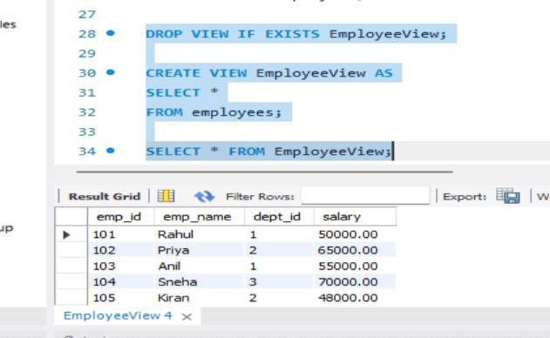

View 2 – Selected Columns
Question: Create a View showing employee ID, employee name and salary only.

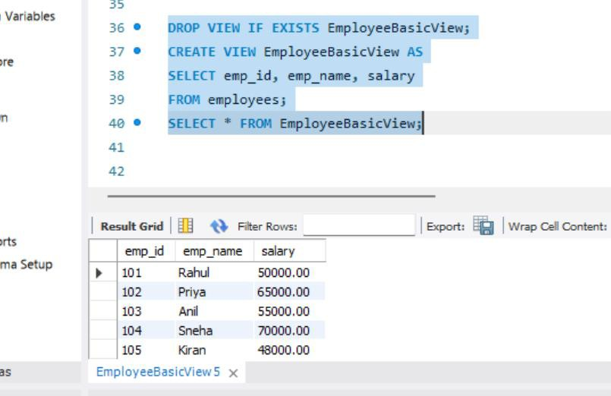

View 3 – High Salary Employees
Question: Create a View that displays employees earning more than 55000.

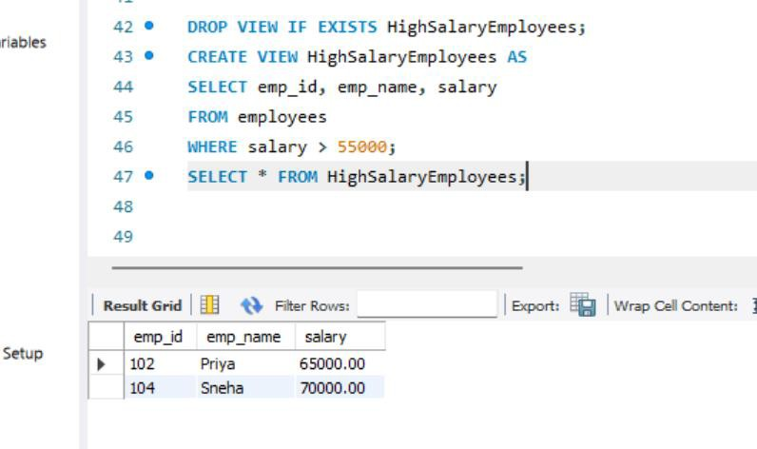

View 4 – Employee and Department using JOIN
Question: Create a View that displays employee name, department name and salary.

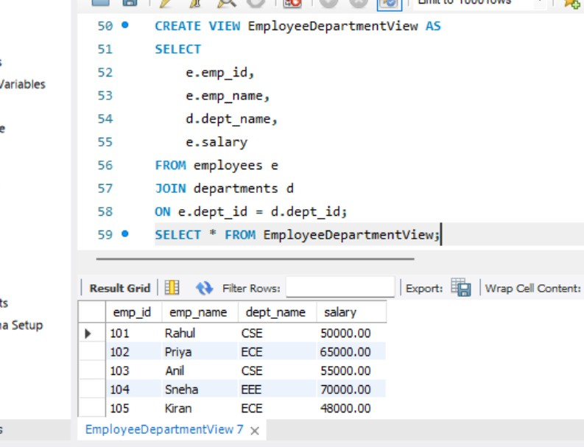

View 5 – Employees from a Particular Department Question: Create a View that displays only CSE employees.
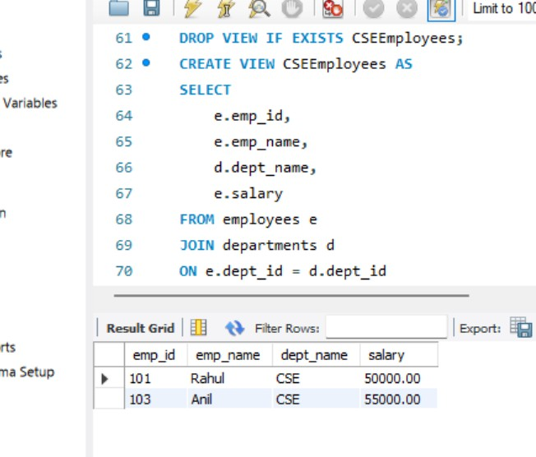

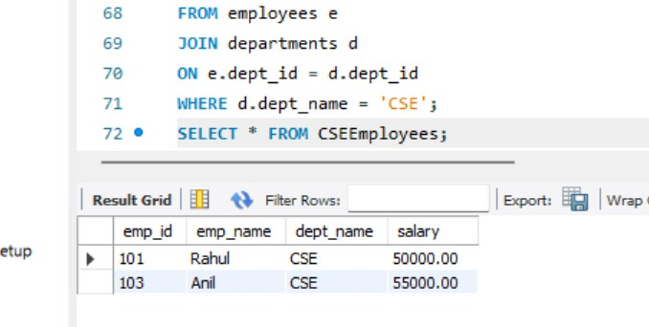

View 6 – Department-wise Average Salary
Question: Create a View using GROUP BY and AVG() to display department-wise average salary.

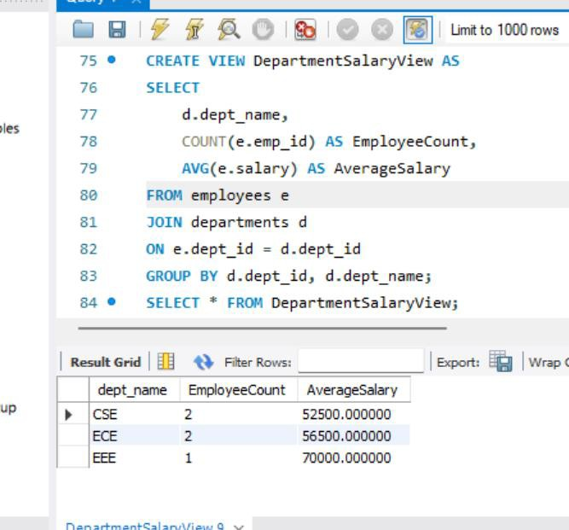

View 7 – Departments with Average Salary Above 55000
Question: Create a View that displays departments whose average salary is greater than 55000.

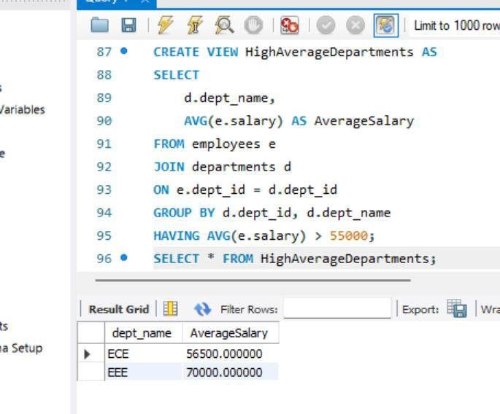

View 8 – Salary Range View
Question: Create a View that displays employees with salary between 50000 and 70000.

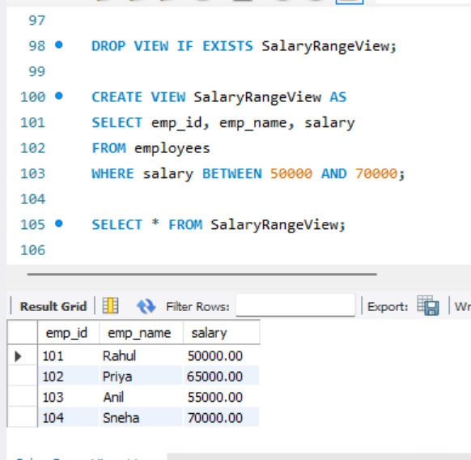

View 9 – View with Calculated Column
Question: Create a View that displays employee name, monthly salary and annual salary.

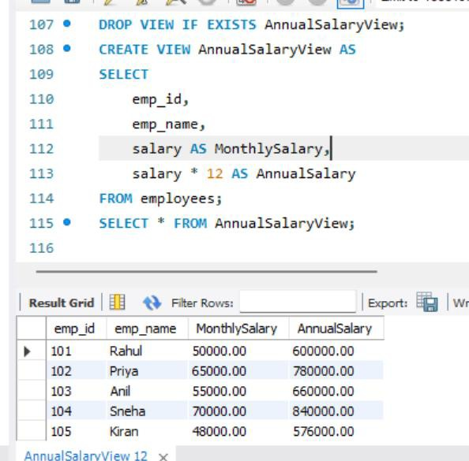

View 10 – Update Data Through a Simple View
Question: Create a simple single-table View and update an employee's salary through the View.

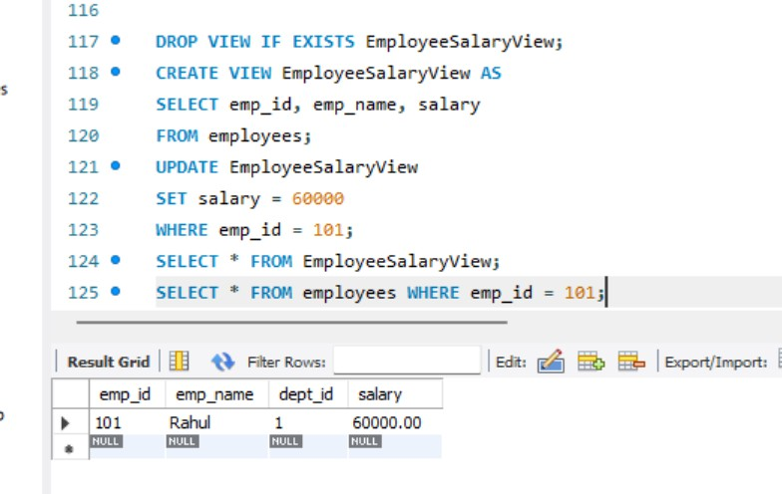

View 11 – CREATE OR REPLACE VIEW
Question: Modify an existing View so that it displays employee name and salary only.

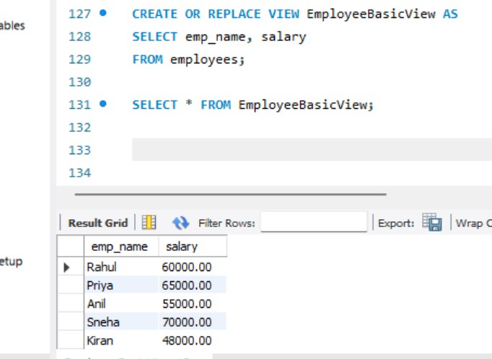

View 12 – View Definition
Question: Display the SQL statement used to create a View.

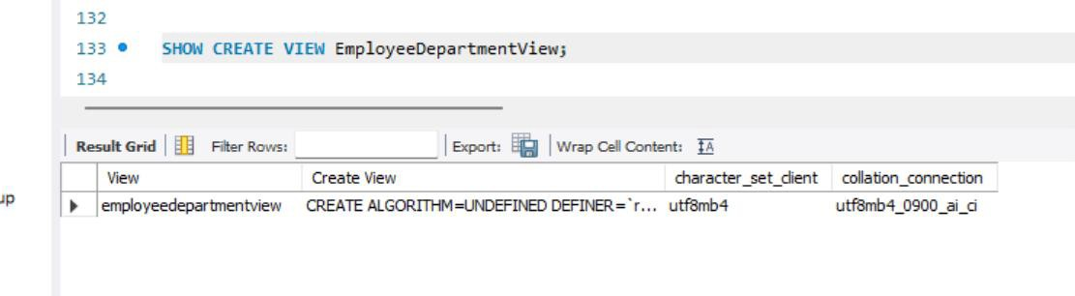
View 13 – List All Views
Question: Display all Views available in the current database.

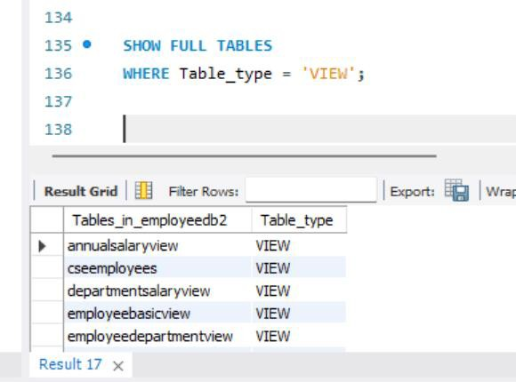

View 14 – Drop a View
Question: Remove an existing View from the database.
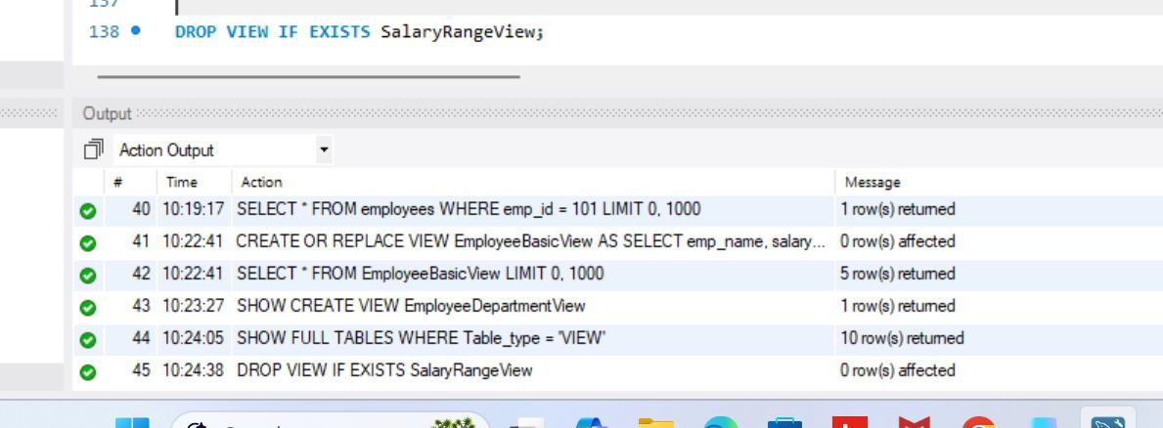

6. Student Practice Tasks
- Create a View showing only emp_id, emp_name and salary.
- Create a View for employees earning more than 60000.
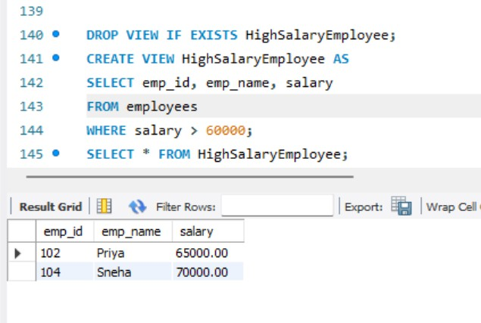
- Create a View showing employee name, department name and salary using JOIN.

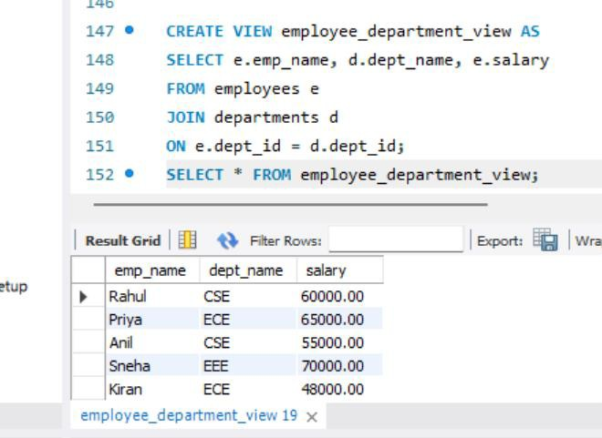
- Create a View showing only ECE employees.
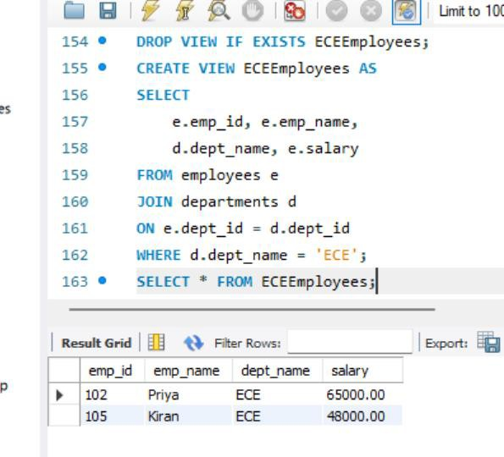
- Create a View showing department-wise employee count.

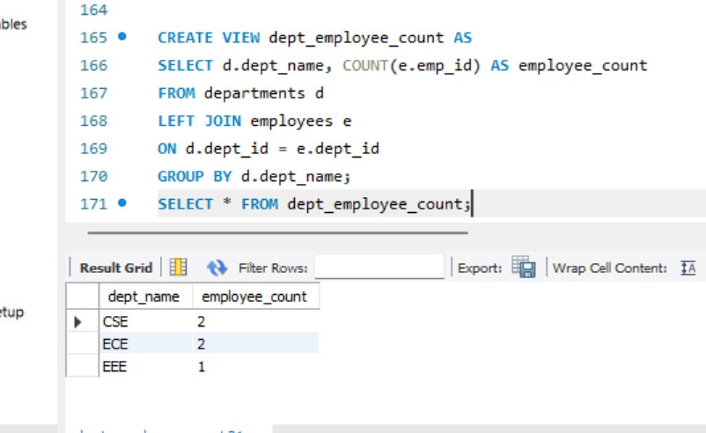
- Create a View showing department-wise maximum salary.
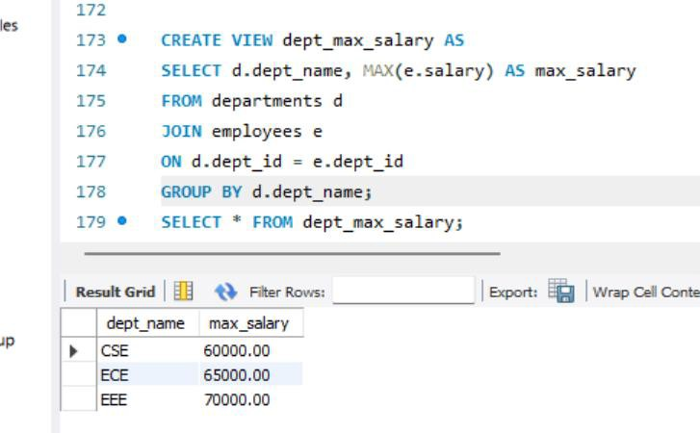
- Create a View showing departments whose average salary is greater than 50000.

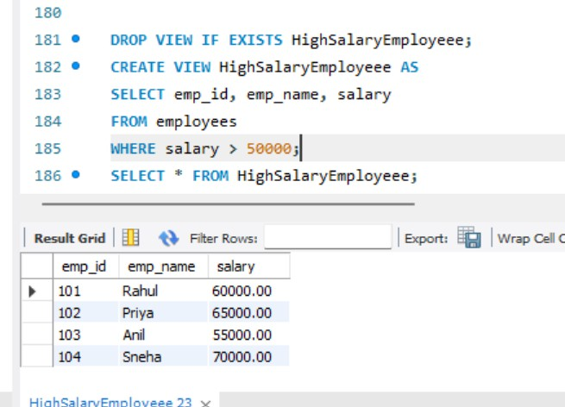
- Create a View with employee name, salary and annual salary.
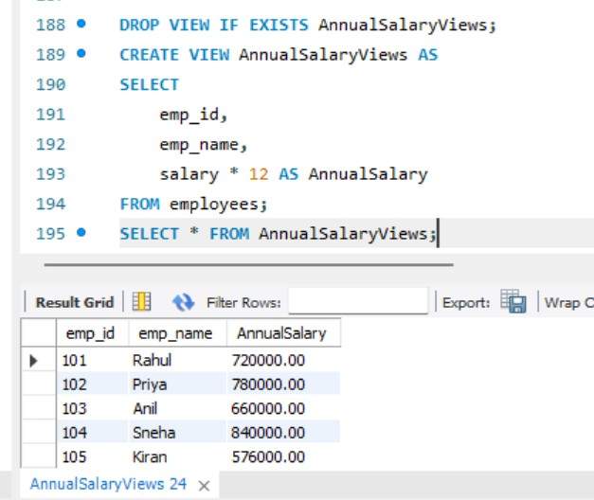
- Update an employee's salary through a simple View and verify the base table.

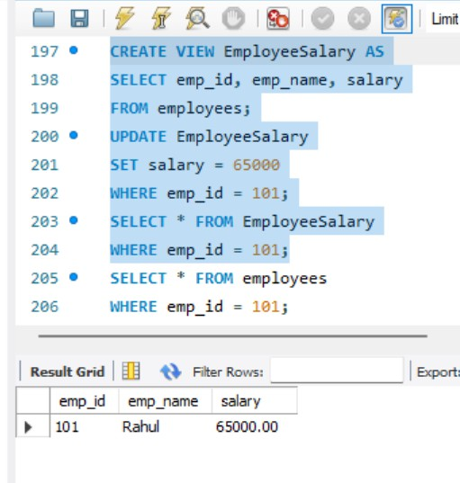

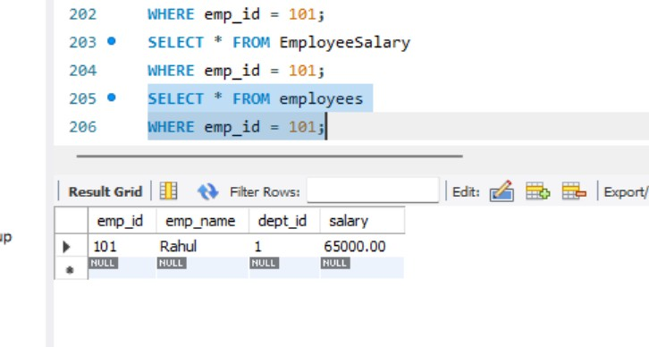
- Use SHOW CREATE VIEW to display the definition of a View.

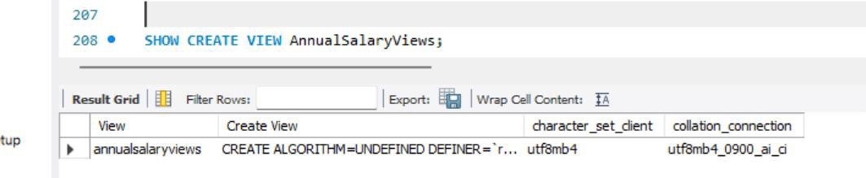
- List all Views in the database.

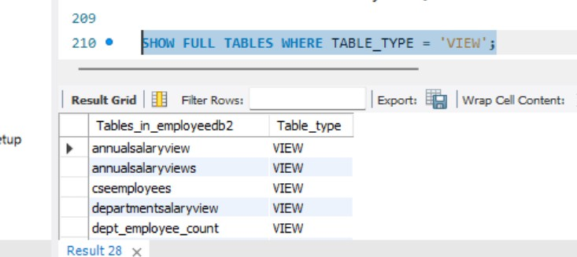
- Drop a View and verify that it no longer appears in the list.
